Mesirov Lab Tools for Genomic Analysis Workshop 8/16/24

To get the most out of the workshop, please read the following regarding the software that will provide the best user experience for the workshop and pre-workshop activities that will make sure you are prepared for the workshop. If you have any questions, please contact genepattern-team@broadinstitute.org.

# Workshop Prerequisites

To participate in this workshop, you will need the following:

* **A modern web browser** (Google Chrome or Netscape Firefox recommended). You can go to<https://browsehappy.com/> to get the latest version of your preferred browser.
* **A Genomics to Notebook (g2nb) account**. Go tohttps://www.g2nb.org/, and click Launch g2nb (in the top right corner). You will see the login screen with the following login choices:

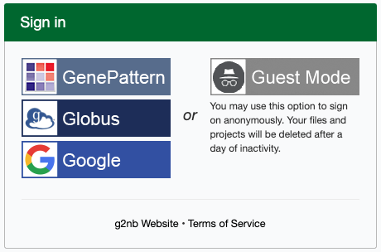

* + Select the GenePattern option.
  + You will be prompted to enter a username and password. **Please do not use special characters or spaces in your username.** This registration will also automatically create an account for you on the GenePattern cloud server,<https://cloud.genepattern.org>.
  + Remember your login information. You will use it for both the GenePattern and g2nb sections of the workshop.
* **A desktop IGV application**. Go to <https://igv.org/doc/desktop/#DownloadPage> and follow the instructions for your operating system. You should select the “Java Included” version of IGV.

# Pre-workshop Activities

Before the start of the workshop, please complete the following:

* **Download IGV sample data**. There are 3 folders in [this shared Google Drive](https://drive.google.com/drive/folders/1uOazAUOvzgXw3zfP2VlZYEjfKRUIXJLv?usp=share_link). Please download them to the computer you will be using for the workshop. To do this:
  + Select all 3 folders
  + Click the Download button
  + It will take a few moments - you will see a popup notification “Preparing Download”
  + Save the data to a location on your computer that is accessible and convenient.

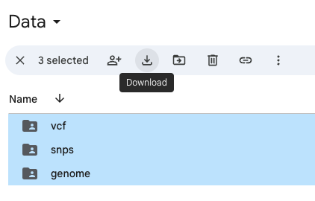

* **Go through the g2nb tutorial notebook**. To do this:
  + Go to [www.g2nb.org](http://www.g2nb.org)
  + Click Launch g2nb
  + You will see a tutorial notebook in your g2nb account:

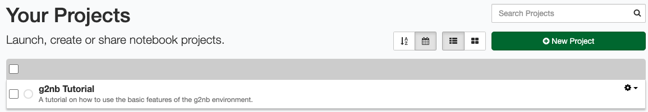

* + Click on **g2nb Tutorial** to launch the notebook.
  + Go through the exercises in the notebook.